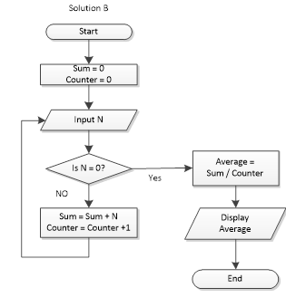

#include <iostream>

#include <cmath>

using namespace std;

int main ()

{

int sum = 0;

int counter = 0;

int average = 0;

int n = 1;

while ( n != 0)

{

cout << "Please input n: ";

cin >> n;

sum = sum + n;

if ( n!=0)

counter = counter + 1;

average = sum / counter;

}

cout << "the average is: " << average << endl;

return (0);

}

// the answer

//

//

// 1, 2, 3, 4, 5, 0

// the average is 3

Start-------> input y -----------> if y>=v --------> output x,v,t

v

-------------------------------------> else y!>=v--------> t++; v=(9\*t\*t) - (4\*t); x = (3\*t\*t\*t) - (2\*t\*t) + 5;

#include <iostream>

#include <cmath>

using namespace std;

int main ()

{

int t = 0;

int v = 0;

int y;

int x;

cout << "Please input y: ";

cin >> y;

while (y >= v)

{

t++;

v = (9\*t\*t) - (4\*t);

x = (3\*t\*t\*t) - (2\*t\*t) + 5;

}

cout << t << endl;

cout << x << endl;

cout << v << endl;

return (0);

}